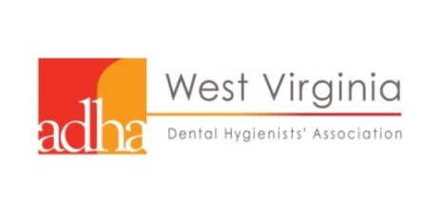
West Virginia Dental Hygienists’ Association
2019 Mid-Winter Session & Continuing Education Event (6 CEUs)
Toyota Technology Center, 2001 Union Carbide Dr., South Charleston, WV 26303
www.myWVDHA.org
Friday, February 15, 2019
Registration
Name:__________________________________________________________
Permanent email address:__________________________________________
ADHA membership number (not your WV RDH license number) __ __ __ __ __ __
Cell phone: _________________________
Registration fee includes: breakfast and luncheon. PayPal is available on myWVDHA.org
Become an ADHA/WVDHA member now and SAVE at https:www.adha.org
Former WVDHA Executive Board member fee $100. Must be a current ADHA member in good standing. Executive Board Position held and years: __________________________
Early Discount applies through January 4, 2019
$130 ADHA member RDH
$180 non-ADHA member RDH, DDS, CDA, other
NO REFUNDS
After February 1, 2019
After January 4, 2019
$130 ADHA member RDH
$210 non-ADHA member RDH, DDS, CDA, other
After January 25, 2019
$180 ADHA member RDH
$230 non-ADHA member RDH, DDS, CDA, other
After February 9, 2019 via PayPal only
$180 ADHA member RDH
$250 non-ADHA member RDH, DDS, CDA, other
Special luncheon dietary needs: ______________________________________

Credit card payment available through PayPal at www.myWVDHA.org or
Make checks payable to West Virginia Dental Hygienists’ Association.
Mail check and registration to: Sharon Stemple Hinchman, MSDH, RDH
116 White Oak Lane, Elkins, WV 26241
“Like” West Virginia Dental Hygienists’ Association on Facebook.

